# Assignment-3

# Convolution Neural Network

|  |  |
| --- | --- |
| AssignmentDate | 6 October 2022 |
| StudentName | M.Subitcha |
| StudentRoll Number | 9517201906049 |
| MaximumMarks | 2Marks |

**#Import necessary libraries**

from tensorflow.keras.models import Sequential

from tensorflow.keras.layers import Dense

from tensorflow.keras.layers import Convolution2D

from tensorflow.keras.layers import MaxPooling2D

from tensorflow.keras.layers import Flatten

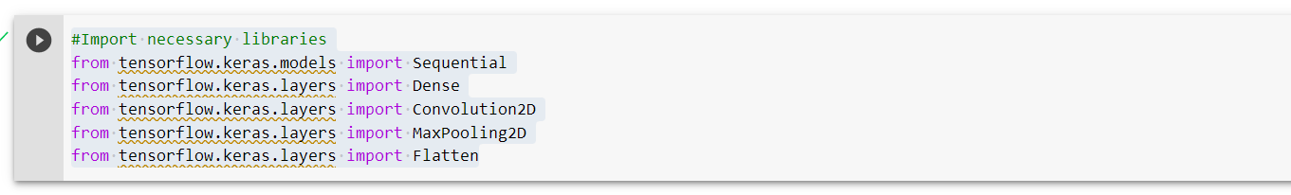

**#Image augmentation**

from tensorflow.keras.preprocessing.image import ImageDataGenerator

train_datagen = ImageDataGenerator(rescale=1./255,shear_range=0.2,zoom_range=0.2,horizontal_flip=True,vertical_flip=True)

test_datagen = ImageDataGenerator(rescale=1./255)



**#Dataset**

x_train=train_datagen.flow_from_directory(r"E:\Flowers\Training",target_size=(128,128),batch_size=32,class_mode="categorical")

x_test=test_datagen.flow_from_directory(r"E:\Flowers\Testing",target_size=(128,128),batch_size=32,class_mode="categorical")

x_train.class_indices

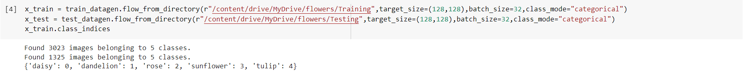

**#Add layers**

model = Sequential()

**#Convolution layer**

model.add(Convolution2D(32,(3,3),input_shape=(128,128,3),activation='relu'))

**#Maxpooling layer**

model.add(MaxPooling2D(pool_size=(2,2)))

**#Flatten layer**

model.add(Flatten())

**#Hidden layer**

model.add(Dense(units=300,kernel_initializer="random_uniform",activation="relu"))

model.add(Dense(units=200,kernel_initializer="random_uniform",activation="relu"))

model.add(Dense(units=5,kernel_initializer="random_uniform",activation="softmax"))

model.summary()

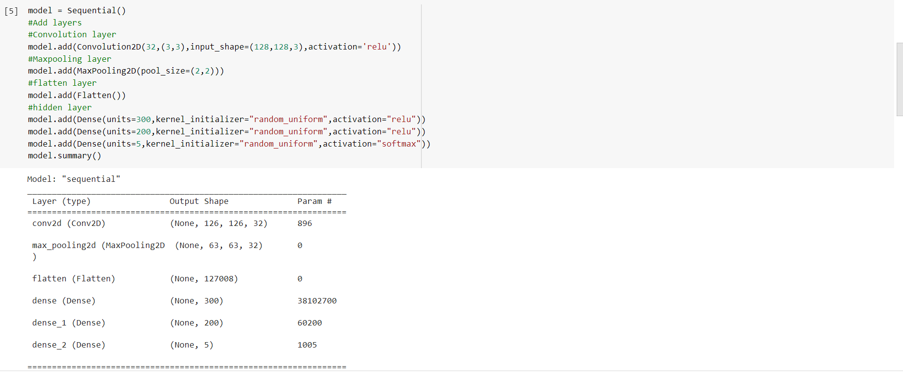

**#Compile the model**

model.compile(loss="categorical_crossentropy",optimizer="adam",metrics=["accuracy"])

**#Fit the model**

model.fit_generator(x_train,steps_per_epoch=75,epochs=15,validation_data=x_test,validation_steps=80)

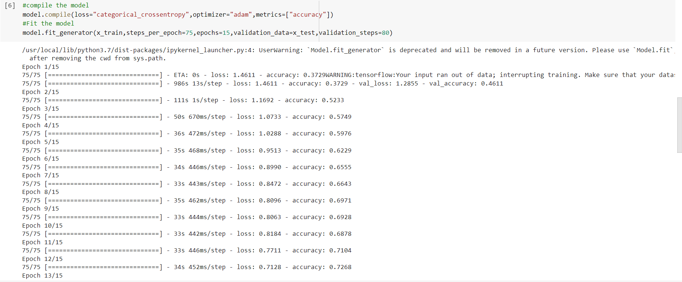

**#Save the model**

model.save("flower.h5")



from tensorflow.keras.models import load_model

from tensorflow.keras.preprocessing import image

import numpy as np

model = load_model("Flower.h5")

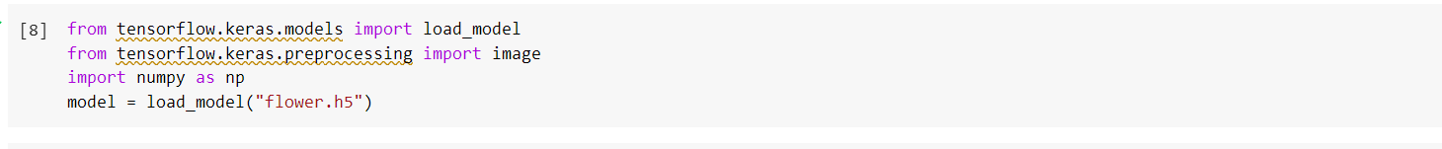

**#Test the model**

img = image.load_img(r"C:\Users\hp\Downloads\rose.jpg",target_size=(128,128))

img

type(img)

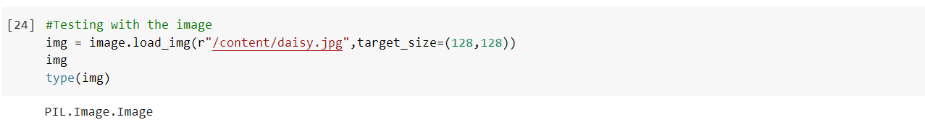

x = image.img_to_array(img)

x

x.shape

x = np.expand_dims(x,axis=0)

x.shape

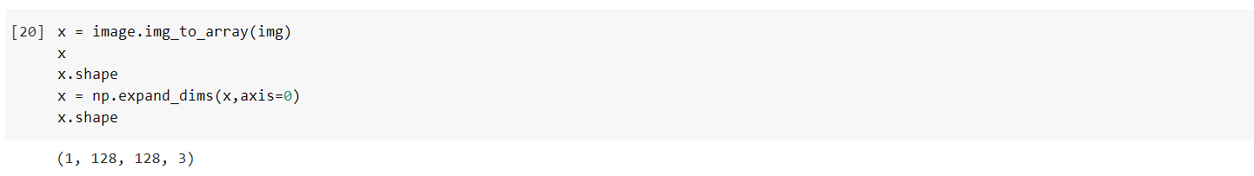

pred_prob = model.predict(x)

pred_prob

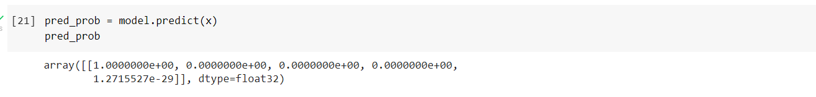

class_name = ["daisy","dandelion","rose","sunfower","tulip"]



pred_id = pred_prob.argmax(axis=1)[0]

pred_id

print("Predicted flower is",str(class_name[pred_id]))

